NEW FORESTS 2000-2020 BASELINE LAND-COVER / LAND-USE MAPPING & HISTORICAL TREE / NON-TREE COVER TRACKING
Draft technical content for final report (vs 003)
TREE COVER TIME SERIES DATASETS
The following time-series data has been generated for the New Forest (NF) mapping AOI:
- 2020 annualised baseline land-cover / land-use dataset
- 2020 annualised (plantation only) tree / non-tree dataset
- 2020 single-date (02-2020) (all) tree / non-tree dataset
- 2020 Quarter 1 (all) tree / non-tree dataset
- 2020 Quarter 2 (all) tree / non-tree dataset
- 2020 Quarter 3 (all) tree / non-tree dataset
- 2020 Quarter 4 (all) tree / non-tree dataset
- 2010 annualised (all) tree / non-tree dataset
- 2010 single-date (01 & 12-2010) (all) tree / non-tree dataset
- 2005 annualised (all) tree / non-tree dataset
- 2000 annualised (all) tree / non-tree dataset
Digital copies of the above time series data is provided in ERDAS Imagine *img raster format, which is ArcGIS directly compatible. Attributes representing zonal statistics for each of the same time-series datasets in relation to individual NF compartment and outgrower polygons is provided in the accompanying ArcGIS shp file.

The 2020 annualised baseline land-cover / land-use dataset has been modelling from 20m resolution Sentinel-2 satellite imagery, using all image acquisitions between 01 January and 31 December 2020; and represents the dominant (annualised) landscape characteristics for that calendar year.
The 2020 annualised (plantation only) tree / non-tree dataset is a direct derivative of the 2020 annualised base land-cover / land-use dataset, and represents the annualised extent of only the plantation class, and excludes all other indigenous woody cover content.
The 2020 single-date (all) tree / non-tree dataset is modelled from single-date, cloud-free Sentinel-2 satellite imagery, acquired 03, 09 and 12 February 2020; using NDVI threshold values to spatially discriminate between tree and non-tree cover areas, with ‘tree’ representing all woody vegetation dominated areas, regardless of whether it is indigenous or planted.

The 2020 Quarter Period tree / non-tree datasets have been modelled from all Sentinel-2 image acquisitions acquired in each 3-month calendar period in 2020, and contain maximum NDVI values per raster cell, per quarter. Quarter Period specific NDVI threshold values have been identified and used to spatially discriminate between tree and non-tree cover areas, with ‘tree’ representing all woody vegetation dominated areas, regardless of whether it is indigenous or planted woody cover.
The 2010 annualised tree / non-tree coverage has been extracted directly from the Global Forest Watch (GFW) 2010 tree cover dataset (https://www.globalforestwatch.org/). The GFW tree cover dataset has been recoded into specific tree cover density ranges, with the content representing the dominant (annualised) landscape characteristics for the 2010 calendar year.
The 2010 single-date (all) tree / non-tree dataset has been modelled from single-date Landsat 5 satellite imagery, using NDVI threshold values to spatially discriminate between tree and non-tree cover areas, with ‘tree’ representing all woody vegetation dominated areas, regardless of whether it is indigenous or planted.
The 2005 annualised tree / non-tree dataset age has been modelled using an integrated combination of the GFW derived 2000 and 2010 tree coverages, and 2005 NDVI datasets derived from archive ‘2005-representative’ 30m resolution Landsat 7 imagery. NDVI threshold values have been used to spatially discriminate between tree and non-tree cover areas, with ‘tree’ representing all woody vegetation dominated areas, regardless of whether it is indigenous or planted.
The 2000 annualised tree / non-tree coverage has been extracted directly from the Global Forest Watch (GFW) 2010 tree cover dataset (https://www.globalforestwatch.org/). The GFW tree cover dataset has been recoded into specific tree cover density ranges, with the content representing the dominant (annualised) landscape characteristics for the 200 calendar year.

STANDARDISATION OF DATA FORMAT
All digital datasets have been re-projected to UTM 36N WGS84, and raster cell aligned (i.e. snapped), using the 20m resolution 2020 base land-cover/ land-use dataset as reference.
STANDARDISED NEW FOREST MAPPING AOI
All digital datasets cover the full extent of the NF mapping areas-of-interest (AOI) in Uganda. The NF mapping AOI contains two separate geographical regions (see Figure 1).
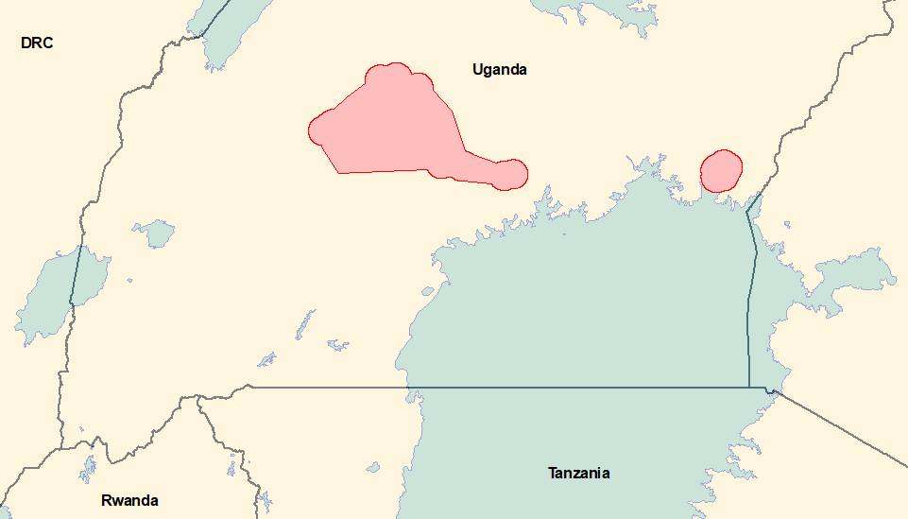
Figure 1. New Forest Mapping Areas-of-Interest (2 x separate geographical regions).

TREE COVER DATASET DESCRIPTIONS
2020 Land-Cover / Land-Use
The 2020 annualised baseline land-cover / land-use dataset has been modelled from 20m resolution Sentinel-2 satellite imagery, using all image acquisitions between 01 January and 31 December 2020; and represents the dominant (annualised) landscape characteristics for that calendar year (see Table 1). Base land-cover content (i.e. vegetation, water and bare ground) has been modelled using a combination of spectral profiling and seasonal occurrence (i.e. temporal permanency). The separation of plantation tree cover from indigenous woody cover is achieved using secondary desk-top mapping and classification techniques, which result in a re-coding of analyst defined areas of the vegetation content generated by the initial automated modelling. Similarly, urban / built-up areas are generated using a combination of independently modelled settlement areas (based on automated classification of 10m Sentinel-2 imagery), and permanent bare areas identified as part of the content outcome from the automated base land-cover modelling. Wetland areas are defined using an integrated combination of terrain-based modelling procedures (based on channel profiling using 30m resolution SRTM data) and vegetation class outcomes from the automated land-cover modelling (see Figure 2a).
Zonal statistical modelling has been used to characterise each of the NF compartment and outgrower plantation vectors with the 2020 base land-cover / land-use characteristics. The associated attributes represent the majority tree cover density class ( MAJ_LC2020) and the percentage cover of the 2020 majority cover class (FRA_LC2020) in the vector polygon. The class codes used in the MAJ_LC2020 field are illustrated in Table 2.
Table 1. Class Legend used in the 2020 Base Land-Cover / Land-Use Dataset
 | Class Name | Definition
1 | Low shrub | Areas (annually) dominated by low woody shrubs, varying between sparse to open cover densities.
2 | Bare | Areas (annually) dominated by non-vegetated, bare ground.
3 | Mixed grass & subsistence-cultivation | Areas (annually) dominated by a mosaic of grassland and some subsistence-scale cultivated land (i.e. small fields). Contains more grass than fields.
4 | Open woodland | Areas (annually) dominated by open woodland / savanna. Significantly more grassland cover than trees / bush cover.
5 | Woodland | Areas (annually) dominated by closed woodland / savanna. Significantly more trees / bush cover than grassland cover.
6 | Thicket | Areas (annually) dominated by dense, closed thicket / low forest.
7 | Forest | Areas (annually) dominated by dense, tall forest
8 | Mixed subsistence-cultivation & grass | Areas (annually) dominated by a mosaic of subsistence-scale cultivated land (i.e. small fields) and grassland. Contains more fields than grassland.
9 | Commercial cultivation | Areas (annually) dominated by a mosaic of commercial-scale cultivated land (i.e. large fields). May also contain clear-felled compartments in commercial timber plantations.
10 | Plantations | Areas (annually) dominated by commercial timber plantations, containing as well developed tree cover.
11 | Settlements | Areas (annually) dominated by settlements and built-up environments. May include roads if roads are of significant width.
12 | Wetlands | Areas (annually) dominated by vegetated (herbaceous) wetlands.
13 | Water | Areas (annually) dominated by open water (either natural and/or man-made).

2020 annualised (plantation only) Tree / Non-Tree
The 2020 annualised (plantation only) tree / non-tree dataset is a derivative of the 2020 annualised base land-cover / land-use dataset. The dataset represents the annualised extent of only standing plantation timber areas, and excludes all indigenous woody cover and any temporary NF clear-felled compartment or outgrower content (see Figure 2b). This dataset includes the 2020 wetland class (from the same 2020 base land-cover dataset as per the sourcing of the plantation class), in order to ensure content compatibility with the other tree / non-tree datasets.
Zonal statistical modelling has been used to characterise each of the NF compartment and outgrower plantation vectors with the 2020 (plantation only) tree cover characteristics. The associated attributes represent the majority tree cover density class (MAJp_2020) and the percentage cover of the 2020 majority cover class (FRAp_2020) in the vector polygon. The class codes used in the MAJp_2020 attribute field are illustrated in Table 2.
2020 Single-Date (All) Tree / Non-Tree
The 2020 single-date (all) tree / non-tree dataset is modelled from single-date, cloud-free Sentinel-2 satellite imagery, acquired on 03, 09 and 12 February 2020, with each date acquisition providing single-date coverage over unique, non-overlapping areas of the NF mapping AOI extent. NDVI threshold values have been used to spatially discriminate between tree and non-tree cover areas, with ‘tree’ representing all woody vegetation dominated areas, regardless of whether it is indigenous or planted (see Figure 2c).
Single-date tree / no-tree coverages provide a date specific representation of landscape characteristics that can potentially illustrate unique, time-dependent plantation clearing activities that could be ‘lost’ within annualised landscape representations.
The NF 2020 single-date tree cover dataset has been re-coded into qualitative tree cover density classes representing low, medium and high cover characteristics (see Figure 1c). In order to remove any possible misinterpretation with other high biomass, non-tree cover landscape characteristics such as wetlands, the wetland class from the 2020 base land-cover dataset has been imbedded into the NF 2010 single-date tree density coverage.
Zonal statistical modelling has been used to characterise each of the NF compartment and outgrower plantation vector with the 2020 single-date tree cover characteristics. The associated attributes represent the majority tree cover density class ( MAJS_2020) and the percentage cover of the 2020 majority cover class (FRAS_2020) in the vector polygon. The class codes used in the MAJS_2020 field are illustrated in Table 2.
2020 Quarter Period Tree / Non-Tree
The 2020 Quarter Period tree / non-tree datasets have been modelled using all Sentinel-2 image acquisitions from within each 3-month calendar period of 2020, and are based on maximum NDVI values per raster cell, per quarter. Quarter Period specific NDVI threshold values have been used to spatially discriminate between tree and non-tree cover areas, with ‘tree’ representing all woody vegetation dominated areas (regardless of whether it is indigenous or planted), in that 3-month window (see Figures 2d, 2e, 2f, 2g). These Quarter Period datasets are therefore similar to the annualised tree / non-tree datasets, but representative of a shorter time-window. The 5-day update cycle of Sentinel-2 facilitates the collection of sufficient cloud-free content within each 3-month window so that all Quarter Period image acquisitions, regardless of cloud-cover content can be used in the compilation of each NDVI maximum value output; without any requirement for pre-selection of only non-cloudy imagery.
All the 2020 NDVI Quarter Period temporal compilations were generated using cloud-based technologies, including cloud-based image data archives . Only the final NDVI maximum value outcome datasets were downloaded for further desk-top processing.
An NDVI value threshold best representing the spatial boundary between woody cover dominant and non-woody cover dominant areas was determined for each Quarter Period dataset, using the same key landscape area for visual reference for each Quarter Period (see Figure 3). Slightly different threshold values were required for each Quarter Period NDVI dataset in order to account for both time dependent atmospheric and seasonal influences.
No GFW adjustment of the 2020 Quarter Period tree cover datasets has been made since the 20m spatial resolution and the 5-day update cycle of Sentinel-5 imagery is considered sufficient accurate. Both the Sentinel-2 Quarter Period and single-date NDVI based tree / non-tree products are the available options for future tree / non-tree mapping going forward into the foreseeable future.
The NF 2020 Quarter Period tree cover datasets have been re-coded into qualitative tree cover density classes representing low, medium and high cover characteristics (see Figure 1c). In order to remove any possible misinterpretation with other high biomass, non-tree cover landscape
characteristics such as wetlands, the wetland class from the 2020 base land-cover dataset has been imbedded into the NF 2010 annualised tree density coverage.
Zonal statistical modelling has been used to characterise each of the NF compartment and outgrower plantation vectors with the 2020 Quarter Period tree cover characteristics. The associated attributes represent the majority tree cover density class (MAJQ1_2020 … MAJQ4_2020) and the percentage cover of the 2005 majority cover class (FRAQ1_2020 … FRAQ4_2020) in the vector polygon. The class codes used in the MAJQ1_2020 field are illustrated in Table 2.
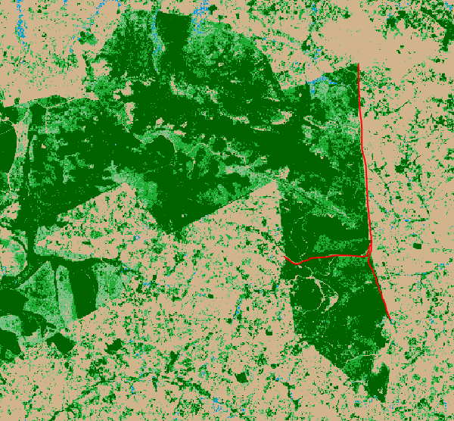
Figure 3. Compartment edge and transecting road features used for consistent and standardised determination of NDVI thresholds for tree / non-tree separation.

2010 Annualised Tree / Non Tree
The annualised 2000 tree / non-tree coverage has been extracted from the Global Forest Watch (GFW) 2010 tree cover dataset (https://www.globalforestwatch.org/). The GFW tree cover datasets represent annually dominant image modelled percent tree cover, ranging between 0 – 100%, irrespective of whether the tree cover is indigenous or planted content. The GFW 2010 tree cover dataset (treecover2010_10N_030.tif) has been used as the sole source of the 2010 NF mapping AOI tree / non-tree content, due to the unavailable of sufficient cloud-free archive Landsat imagery to support either integrated and/or individual Quarter Period mapping. The GFW 2010 continuous field tree cover dataset has been re-coded into tree cover density classes representing 0 - 39, 40 - 49, 50 - 59, 60 - 74 and 75 - 100 percent tree cover (see Figure 2h).
Note that the continuous field format of the GFW tree cover datasets does not discriminate between tree and non-tree landscape characteristics, in the manner of a land-cover / land-use thematic map. It is therefore possible that non-tree landscape vegetation features which have similar spectral characteristics to tree cover may be mis-represented as tree covered regions. The GFW datasets only exclude water features in the tree cover modelling spatial representation.
In order to remove any possible misinterpretation with other high biomass, non-tree cover landscape characteristics such as wetlands, the wetland class from the 2020 base land-cover dataset has been imbedded into the NF GFW 2010 tree density class coverage, on the basis that the location and existence of wetlands is time stable, and that wetlands in existence in 2020 are also likely to have been in existence in 2010. In order to facilitate direct pixel-to-pixel comparison with the 20m cell resolution format of the 2020 baseline land-cover dataset, the GFW 2010 dataset was resampled to 20m from its original 30m format (using Nearest Neighbour protocol), after re-coding to the specific tree-cover density class ranges.
Zonal statistical modelling has been used to characterise each of the NF compartment and outgrower plantation vectors with the 2010 tree cover characteristics. The associated attributes represent the majority tree cover density class (MAJ_2010) and the percentage cover of the 2010 majority cover class (FRA_2010) in the vector polygon. The class codes used in the MAJ_2010 attribute field are illustrated in Table 2.
Note: Despite attempts to create usable NDVI maximum composites for each 4-month Quarter Period in 2009, 2010 and 2011, the scarcity of usable cloud free Landsat 5 coverage over the NF AOI mapping extent in that period did not facilitate the generation of Quarter Period NDVI tree / non-tree cover datasets as additional 2010 representative data. However it was possible to generate a 2010 single-date representative tree / non-tree dataset.
2010 Single-Date Tree / Non-Tree
The 2010 single-date tree / non-tree coverage has been modelled using an integrated combination of the GFW derived 2000 and 2010 tree coverages, and archive ‘2010-representative’ 30m resolution Landsat 5 imagery, acquired in February and December 2010, with each date acquisition providing single-date coverage over unique, non-overlapping areas of the NF mapping AOI extent. The coverage of the February and December 2010 Landsat imagery used to model the 2010 single-date tree / non-tree content is illustrated in Figure 4. In order to ensure continuity and comparability of tree cover representations, the final 2010 single-date NDVI representation of tree cover was spatially adjusted so that it was geographically limited to the combined spatial range of woody cover equal to and exceeding 40% in both the GWF derived annualised 2005 and 2010 tree / non-tree coverages. The assumption being that the 2010 single-date tree cover extent cannot exceed this independently determined woody cover extent.
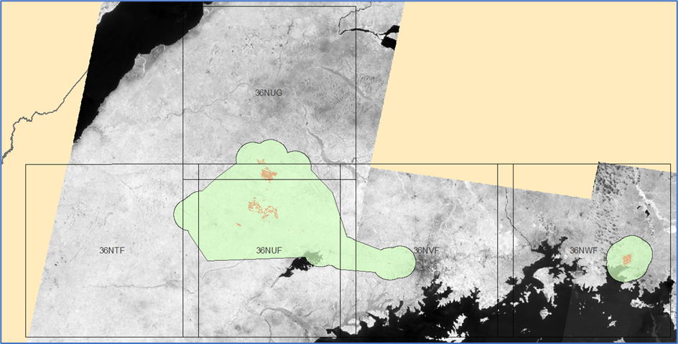
21_01_2010
28_01_2010
05_12_2010
05_12_2010
Figure 4. Single-date NDVI coverages used in 2010 Single-Date Tree Cover Modelling
Single-date tree / no-tree coverages provide a date specific representation of landscape characteristics that can potentially illustrate unique, time-dependent plantation clearing activities that could be ‘lost’ within annualised landscape representations. The final NF 2010 single-date tree cover dataset has been re-coded into qualitative tree cover density classes representing low, medium and high cover characteristics (see Figure 2i).
In order to remove any possible misinterpretation with other high biomass, non-tree cover landscape characteristics such as wetlands, the wetland class from the 2020 base land-cover dataset has been imbedded into the NF 2010 single-date tree density coverage, on the basis that the location and existence of wetlands is time stable, and that wetlands in existence in 2020 are also likely to have been in existence in 2010. In order to facilitate direct pixel-to-pixel comparison with the 20m cell resolution format of the 2020 baseline land-cover dataset, the 2010 single-date dataset was resampled to 20m from its original 30m format (using Nearest Neighbour protocol), after re-coding to the specific tree-cover density class ranges.
Zonal statistical modelling has been used to characterise each of the NF compartment and outgrower plantation vectors with the 2010 single-date tree cover characteristics. The associated attributes represent the majority tree cover density class ( MAJS_2010) and the percentage cover of the 2005 majority cover class (FRAS_2010) in the vector polygon. The class codes used in the MAJS_2010 field are illustrated in Table 1
2005 Annualised Tree / Non-Tree
The 2005 annualised tree / non-tree coverage has been modelled using an integrated combination of the GFW derived 2000 and 2010 tree coverages, and archive ‘2005-representative’ 30m resolution Landsat 7 imagery. The term ‘2005-representative’ imagery is used since the following archive Landsat 7 image temporal compilations were used:
- 2004 Quarter 2 (April, May, June)
- 2004 Quarter 4 (October, November, December)
- 2005 Quarter 1 (January, February, March)
- 2005 Quarter 2 (April, May, June)
- 2005 Quarter 3 (July, August, September)
- 2005 Quarter 4 (October, November, December)
- 2006 Quarter 1 (January, February, March)

Each Quarter Period dataset represented the maximum recorded NDVI value per pixel cell column from all Landsat 7 image acquisitions during that temporal quarter window, based on the 16-day update cycle of Landsat. NDVI data values from each Quarter Period dataset were then combined into a single NDVI (maximum value) dataset representing the annualised 2005 landscape. The selection of Quarter Period NDVI maximum value datasets used in the final 2005 annualised compilation excluded any Quarter Period datasets that contained visually obvious cloud-cover impacted content. The 16-day update cycle of Landsat does not always facilitate the collection of sufficient cloud-free content, even within a 3-month (i.e. Quarter Period) window. The geographic distribution of these Quarter Period temporal compilations across the NF mapping AOI is illustrated in Figure 5.

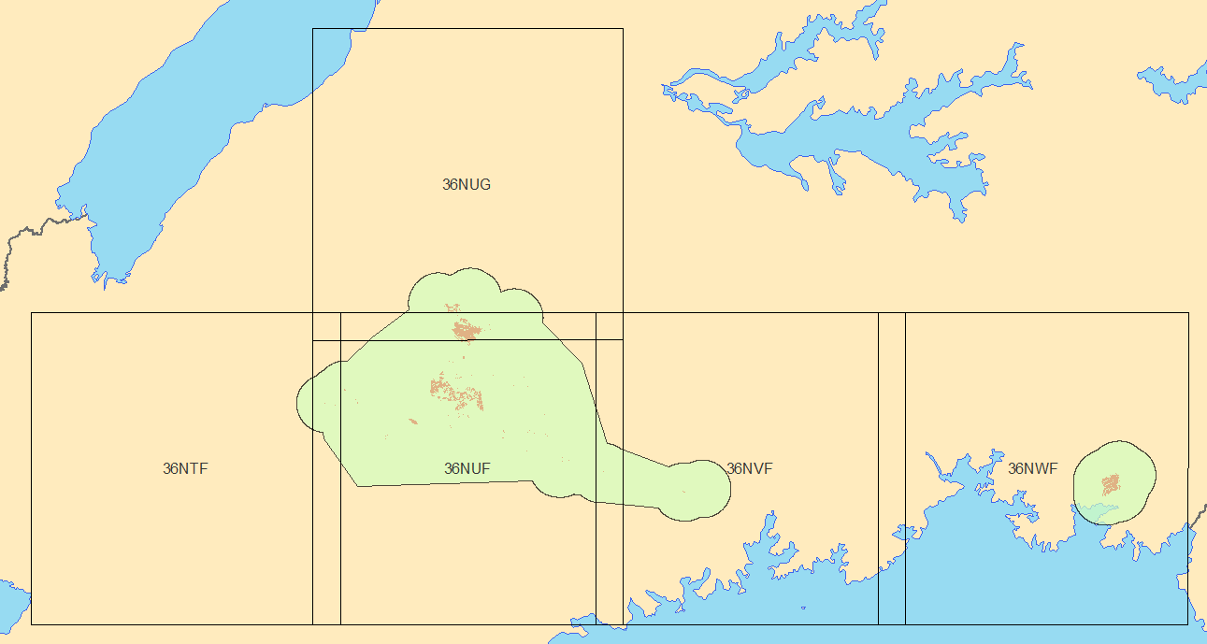
2005 Q2
2005 Q3
2005 Q4
2004 Q4
2005 Q3
2005 Q4
2006 Q1
2004 Q2
2005 Q1
2005 Q3
2006 Q1
2004 Q4
2005 Q3
2005 Q4
2006 Q1
2004 Q4
2005 Q3
2005 Q4
2006 Q1

Figure 5. NDVI temporal compilations used in 2005 Annualised Tree Cover Modelling
All the initial 2005 NDVI Quarter Period temporal compilations were generated using cloud-based technologies, including cloud-based image data archives. Only final NDVI maximum datasets were downloaded for further desk-top processing.
A NDVI value threshold was determined for each individual 2005 Quarter Period NDVI maximum value dataset that best represented the threshold between woody cover dominant and non-woody cover dominant areas in that temporal window, using the same key landscape area for visual reference in each case. Different NDVI thresholds were used for each Quarter Period NDVI dataset, in order to account for any time dependent atmospheric and seasonal influences.
In order to ensure both continuity and comparability of tree cover representations, the final 2005 annualised NDVI representation of tree cover was spatially adjusted so that it was geographically limited to the combined spatial range of woody cover equal to and exceeding 40% in both the GWF derived annualised 2005 and 2010 tree / non-tree coverages. The assumption behind this being that the GFW datasets are definitive, globally accepted reference datasets, and that the intervening 2005 landscape is unlikely to have a more extensive woody cover than in 2000, and that were woody cover is less in 2005, it is likely to be where it has been lost between 2000 and 2010.
The final NF 2010 annualised tree cover dataset has been re-coded into qualitative tree cover density classes representing low, medium and high cover characteristics (see Figure 2i). In order to remove any possible misinterpretation with other high biomass, non-tree cover landscape characteristics such as wetlands, the wetland class from the 2020 base land-cover dataset has been imbedded into the NF 2005 annualised tree density coverage, on the basis that the location and existence of wetlands is time stable, and that wetlands in existence in 2020 are also likely to have been in existence in 2000.
In order to facilitate direct pixel-to-pixel comparison with the 20m cell resolution format of the 2020 baseline land-cover dataset, the 2005 annualised dataset was resampled to 20m from its original 30m format (using Nearest Neighbour protocol), after re-coding to the specific tree-cover density class ranges.
Zonal statistical modelling has been used to characterise each of the NF compartment and outgrower plantation vectors with the 2005 annualised tree cover characteristics. The associated attributes represent the majority tree cover density class ( MAJ_2005) and the percentage cover of the 2005 majority cover class (FRA_2005) in the vector polygon. The class codes used in the MAJ_2005 field are illustrated in Table 2.
2000 Annualised Tree / Non Tree
The 2000 annualised tree / non-tree coverage has been extracted from the Global Forest Watch (GFW) 2000 tree cover dataset (https://www.globalforestwatch.org/). The GFW tree cover datasets represent the annually dominant image modelled percent tree cover, ranging between 0 – 100%, irrespective of whether the tree cover is indigenous or planted content. The GFW 2000 tree cover dataset (Hansen_GFC-2020-v1.8_treecover2000_10N_030.tif) has been used as the sole source of the 2000 NF mapping AOI tree cover. Note that the continuous field format of the GFW tree cover datasets does not discriminate between tree and non-tree landscape characteristics, in the manner of a land-cover / land-use thematic map. It is therefore possible that non-tree landscape features which have similar image data characteristics to tree cover densities may be mis-represented as tree covered regions. The GFW datasets only exclude water features in the tree cover modelling spatial representation.
The GFW 2000 continuous field tree cover dataset has been re-coded into tree cover density classes representing 0 – 39, 40 – 49, 50 – 59, 60 – 74 and 75 – 100 percent tree cover (see Figure 2j). In order to remove any possible misinterpretation with other high biomass, non-tree cover landscape characteristics such as wetlands, the wetland class from the 2020 base land-cover dataset has been imbedded into the NF GFW 2000 tree density class coverage, on the basis that the location and existence of wetlands is time stable, and that wetlands in existence in 2020 are also likely to have been in existence in 2000. In order to facilitate direct pixel-to-pixel comparison with the 20m cell resolution format of the 2020 baseline land-cover dataset, the GFW 2000 dataset was resampled to 20m from its original 30m format (using Nearest Neighbour protocol), after re-coding to the specific tree-cover density class ranges.
Zonal statistical modelling has been used to characterise each of the NF compartment and outgrower plantation vectors with the 2000 tree cover characteristics. The associated attributes represent the majority tree cover density class (MAJ_2000) and the percentage cover of the 2000 majority cover class (FRA_2000) in the vector polygon. The class codes used in the MAJ_2000 attribute field are illustrated in Table 2.

Comparison Between 2000 and 2010 Annualised GFW Derived Tree Cover Datasets
A direct comparison between the two equivalent GFW derived annualised 2000 and 2010 tree cover representation for the NF mapping AOI extent (see Figures 2j and 2h) clearly shows that there has been a significant reduction in overall tree cover between 2000 and 2010 (i.e. less over green class coverage, and reduction in tree cover densities / green-tones where tree cover remains in 2010).
If this 2000 – 2010 reduction in tree cover densities is (as is highly likely to be), a result of anthropogenic clearing of indigenous tree and bush cover, then it is possible that some of the NF compartment and outgrower polygons could show a high tree cover density content in 2000, followed by initially lower tree cover densities in subsequent years, prior to the current timber crop becoming evident in more recent years (i.e. 2020). This sequence of changes may very well represent a loss of indigenous woody cover, followed by an eventual replacement by planted timber, but since neither the source GFW datasets nor the derived tree cover density classes discriminate between indigenous and planted timber content, this cannot be categorically confirmed. In order to do this would require the production of a historical 2000 land-cover / land-use dataset within which these woody classes could be represent as separate thematic classes. Prior to a historical baseline land-cover / land-use dataset being available, it is considered reasonable to assume that should a NF polygon show a significant tree content in 2000, followed by either a significant reduction or total loss of tree cover in intervening years (i.e. 2005, 2010), and then confirmation of timber crop content in 2020, then the current timber crop represents a re-planting of an area of indigenous woody cover that was previously lost / cleared.
The NDVI-modelled annualised 2005 tree / non-tree coverage shows a closer spatial tree cover pattern characteristics to the annualised 2000 GFW derived dataset than to the far less woody cover content of the annualised 2010 GFW derived dataset. Although direct class-to-class comparison is not possible (since the 2000 and 2010 GFW derived datasets are based on continuous field woody cover densities and the 2005 dataset on interpreted thematic content), the datasets would appear to indicate that the bulk of landscape indigenous woody cover clearing occurred between 2005 and 2010.

Examples of Tree / Non-Tree Time Series Data Interpretation.
The combined ArcGIS (shp) format file containing all NF compartment and outgrower areas has been populated with the time-series tree / non-tree attributes as detailed previously. Table 3 documents the time-series attributes that have been generated. Figure 6 provides an example of these attributes, using NF compartment (LID) 3045 as the example polygon.
Table 3 Tree / Non-Tree Times Series Attributes in ArcGIS shape file.
Attribute | Description
LID | New Forest unique plantation polygon identifier
TYPE | New Forest unique content classifier
WC | New Forest timber species classifier
GENUS | New Forest timber genus classifier
PDATE | New Forest defined planting date
tmp_PYEAR | Planting year
AGE_2000x | Planted tree age in 2000, defined in years (to match time-series modelling content)
AGE_2005x | Planted tree age in 2005, defined in years (to match time-series modelling content)
AGE_2010x | Planted tree age in 2010, defined in years (to match time-series modelling content)
AGE_2020x | Planted tree age in 2020, defined in years (to match time-series modelling content)
MAJ_2000 | Majority modelled tree class from 2000 annualised (all) tree / non-tree coverage
FRA_2000 | Fraction (%) cover of majority tree class from MAJ_2000
F2000gfw_(number) | Fraction (pixel count) of all classes from 2000 annualised (all) tree / non-tree coverage
MAJ_2005 | Majority modelled tree class from 2005 annualised (all) tree / non-tree coverage
FRA_2005 | Fraction (%) cover of majority tree class from MAJ_2005
F2005l5_(number) | Fraction (pixel count) of all classes from 2005 annualised (all) tree / non-tree coverage
MAJ_2010 | Majority modelled tree class from 2010 annualised (all) tree / non-tree coverage
FRA_2010 | Fraction (%) cover of majority tree class from MAJ_2010
F2010gfw_(number) | Fraction (pixel count) of all classes from 2010 annualised (all) tree / non-tree coverage
MAJS_2010 | Majority modelled tree class from 2010 single-date (all) tree / non-tree coverage
FRAS_2010 | Fraction (%) cover of majority tree class from MAJS_2010
F2010s_(number) | Fraction (pixel count) of all classes from 2010 single-date (all) tree / non-tree coverage
MAJQ1_2020 | Majority modelled tree class from 2020 Quarter Period 1 (all) tree / non-tree coverage
FRAQ1_2020 | Fraction (%) cover of majority tree class from MAJQ1_2020
F20200q1_(number) | Fraction (pixel count) of all classes from 2020 Quarter Period 1 (all) tree / non-tree coverage
MAJQ2_2020 | Majority modelled tree class from 2020 Quarter Period 2 (all) tree / non-tree coverage
FRAQ2_2020 | Fraction (%) cover of majority tree class from MAJQ2_2020
F20200q2_(number) | Fraction (pixel count) of all classes from 2020 Quarter Period 2 (all) tree / non-tree coverage
MAJQ3_2020 | Majority modelled tree class from 2020 Quarter Period 3 (all) tree / non-tree coverage
FRAQ3_2020 | Fraction (%) cover of majority tree class from MAJQ3_2020
F20200q3_(number) | Fraction (pixel count) of all classes from 2020 Quarter Period 3 (all) tree / non-tree coverage
MAJQ4_2020 | Majority modelled tree class from 2020 Quarter Period 4 (all) tree / non-tree coverage
FRAQ4_2020 | Fraction (%) cover of majority tree class from MAJQ4_2020
F20200q4_(number) | Fraction (pixel count) of all classes from 2020 Quarter Period 4 (all) tree / non-tree coverage
MAJS_2020 | Majority modelled tree class from 2020 single-date (all) tree / non-tree coverage
FRAS_2020 | Fraction (%) cover of majority tree class from MAJS_2020
F2020s_(number) | Fraction (pixel count) of all classes from 2020 single-date (all) tree / non-tree coverage
MAJL_LC2020 | Majority modelled tree class from 2020 base land-cover (all classes) coverage
FRA_LC2020 | Fraction (%) cover of majority tree class from MAJ_LC2020
F2020lc_(number) | Fraction (pixel count) of all classes from 2020 base land-cover (all classes) coverage
MAJP_2020 | Majority modelled tree class from 2020 plantation only class coverage
FRAP_2020 | Fraction (%) cover of majority tree class from MAJP_2020
F2020lcp_(number) | Fraction (pixel count) of all classes from 2020 plantation only coverage

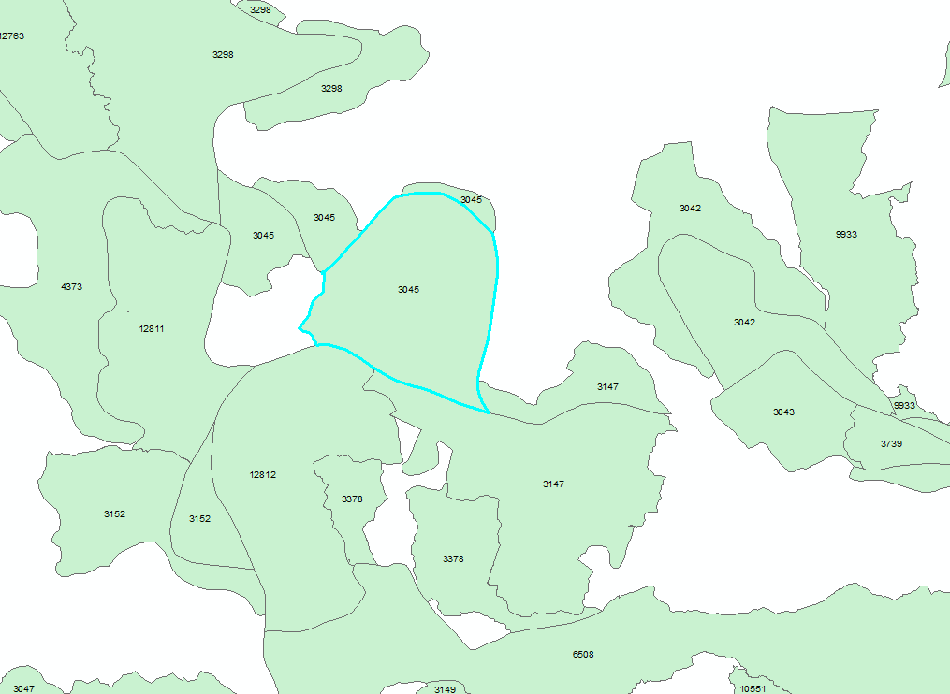
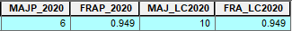
Figure 6. New Forest Compartment Polygon LID 3045 (with associated time-series tree / non-tree attributes). Note that ‘tmp_PYEAR’ and ‘test_PYR’ are new generated attributes that define the compartment planting years (irrespective of month), and which are used to generate the ‘AGE_YEARx’ attributes that define the timber age in years at the same years as key time-series tree / non-tree mapping.
Using NF compartment LID 3045 as an example, the following time-series information can be generated (LID 3045 was planted with Pine:
Attribute | Tree Class | % cover | Description / interpretation
MAJ_2000 | 4 | 0.377
MAJ_2005 | 1 | 0.349
MAJS_2010 | 6 | 0.451
MAJ_2010 | 4 | 0.

(Note 2) – Pines and NDVI adjustment.

Table 2. Tree Cover Class Attribute Codes
 | MAJ_2000 | MAJ_2005 | MAJ_2010 | MAJS_2010 | MAJP_2010 | MAJQ1_2020  MAJQ2_2020  MAJQ3_2020  MAJQ4_2020 | MAJS_2020 | MAJ_LC2020
Temporal representation | annualised | annualised | annualised | single-date | annualised | Quarter Period | single-date | annualised
Class
1 | No tree | No tree | No tree | No tree | No tree | No tree | No tree | Low shrub
2 | Wetland 2020 | Wetland 2020 | Wetland 2020 | Wetland 2020 | Wetland 2020 | Wetland 2020 | Wetland 2020 | Bare ground
3 | No data | No data | No data | No data | No data | No data | No data | Mixed grass & subs-cultivated
4 | Tree 40 – 49% | Low tree | Tree 40 – 49% | Low tree | No data | Low tree | Low tree | Open woodland
5 | Tree 50 – 59% | Medium tree | Tree 50 – 59% | Medium tree | No data | Medium tree | Medium tree | Woodland
6 | Tree 60 – 74% | High tree | Tree 60 – 74% | High tree | Tree Plantations | High tree | High tree | Thicket
7 | Tree 75 – 100% | No data | Tree 75 – 100% | No data | No data | No data | No data | Forest
8 |  |  |  |  |  |  |  | Mixed subs-cultivated & grass
9 |  |  |  |  |  |  |  | Commercial cultivated
10 |  |  |  |  |  |  |  | Plantations
11 |  |  |  |  |  |  |  | Settlements
12 |  |  |  |  |  |  |  | Wetlands
13 |  |  |  |  |  |  |  | Water
Data source | Global Forest Watch | Landsat imagery (NDVI) | Global Forest Watch | Landsat imagery  (NDVI) | Sentinel imagery  (NDVI) | Sentinel imagery  (NDVI) | Sentinel imagery  (NDVI) | Sentinel imagery

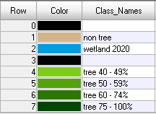
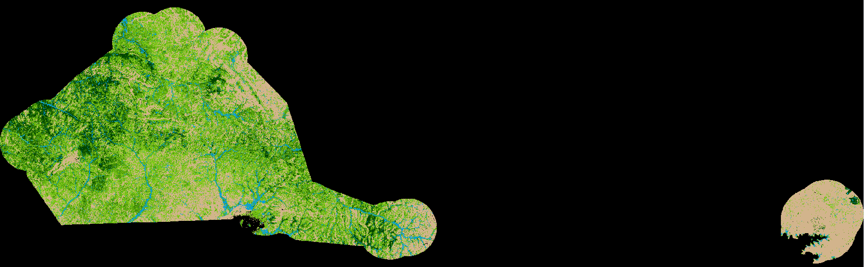

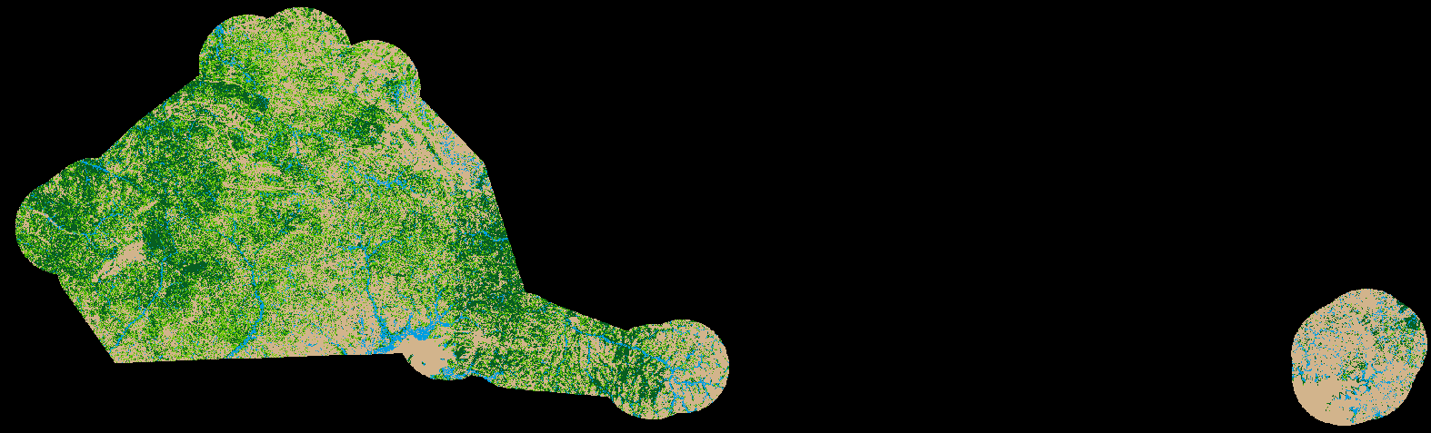
Figure 2j. NF Mapping AOI: 2000 annualised GFW derived Tree Cover Classes
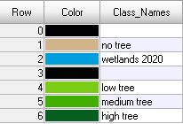
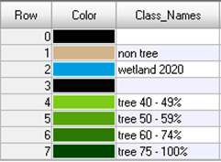

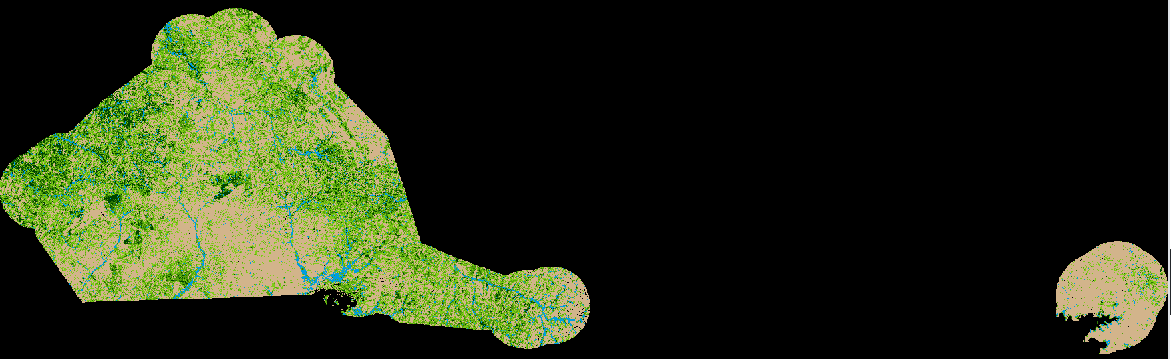
Figure 2i. NF Mapping AOI: 2005 annualised NDVI-modelled Tree Cover Classes


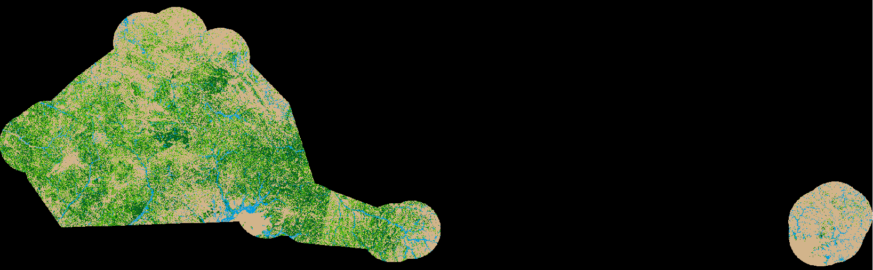
Figure 2h NF Mapping AOI: 2010 annualised GFW derived Tree Cover Classes


Figure 2i NF Mapping AOI: 2010 single-date Tree Cover Classes

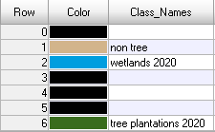
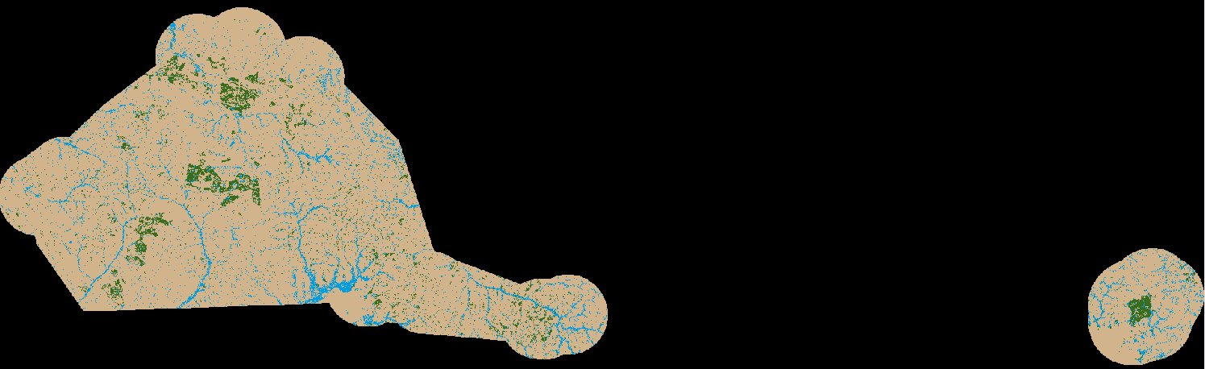

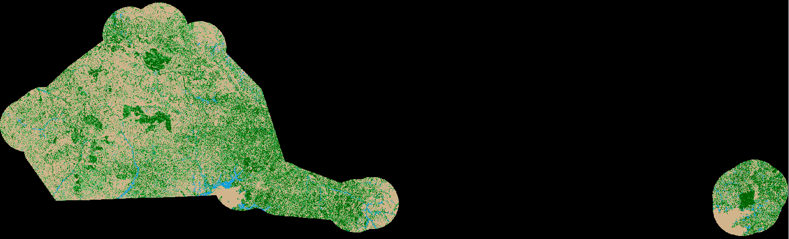
Figure 2b NF Mapping AOI: 2020 annualised (plantation-only) Tree Cover Classes


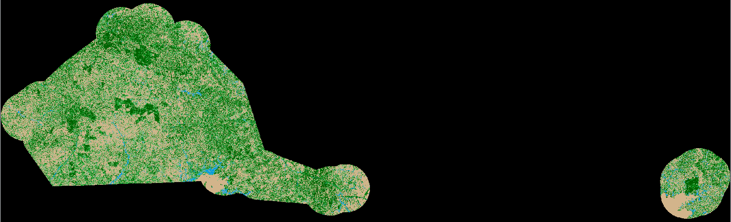
Figure 2d NF Mapping AOI: 2020 Quarter 1 NDVI-modelled Tree Cover Classes


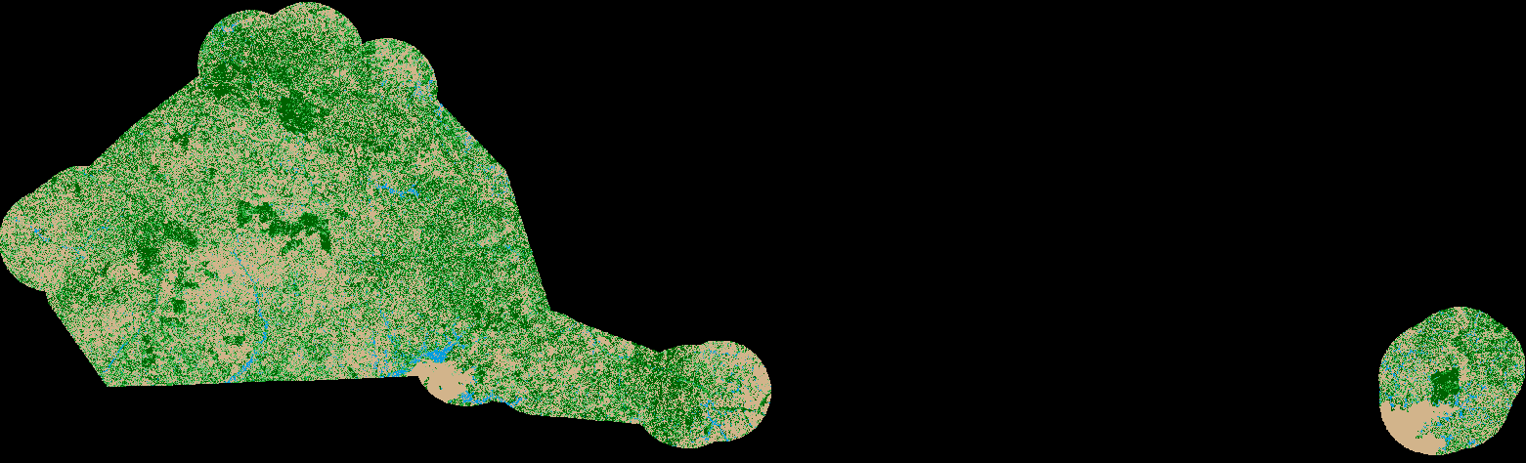
Figure 2e NF Mapping AOI: 2020 Quarter 2 NDVI-modelled Tree Cover Classes


Figure 2f NF Mapping AOI: 2020 Quarter 3 NDVI-modelled Tree Cover Classes


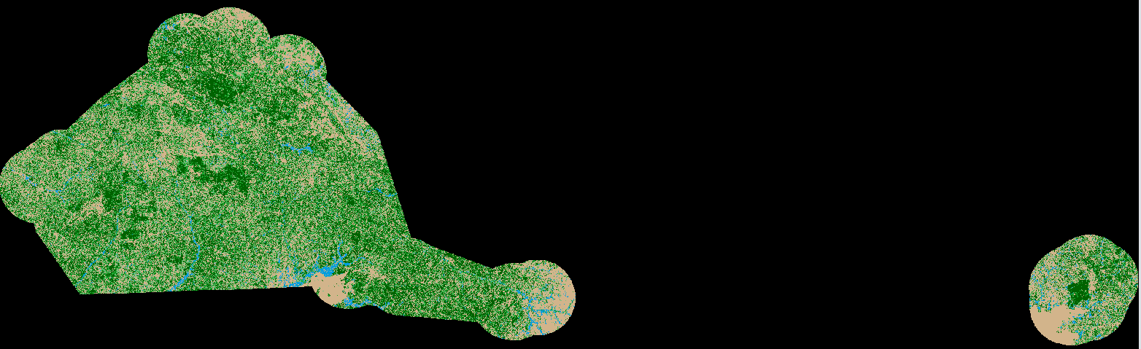

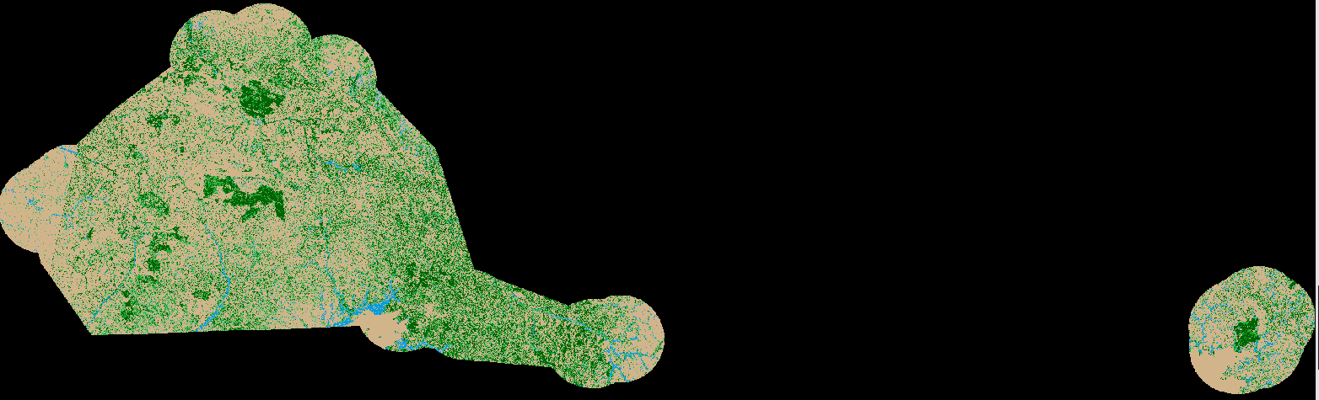
Figure 2g NF Mapping AOI: 2020 Quarter 4 NDVI-modelled Tree Cover Classes


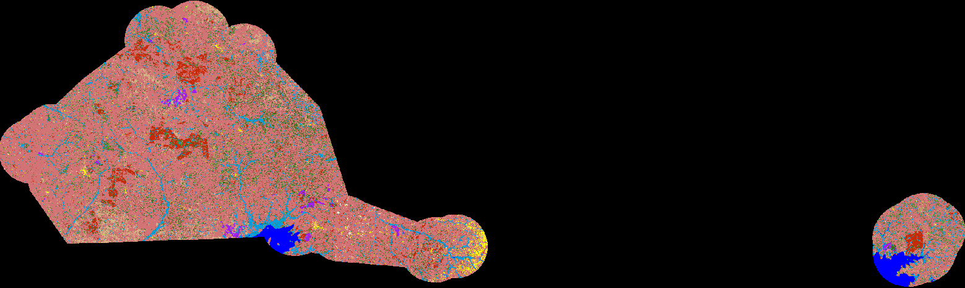
Figure 2e NF Mapping AOI: 2020 Single-date NDVI-modelled Tree Cover Classes
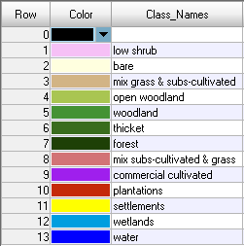

Figure 2a NF Mapping AOI: 2020 Base Land-Cover / Use Classes

Normalised Difference Vegetation Index (NDVI): a spectrally-derived index of above ground photosynthetically active biomass. The NDVI is a globally recognised index of plant growth and vigour. Selective NDVI threshold values can assist in the determination and delineation of above ground vegetation characteristics.
Shuttle Radar Topography Mission (SRTM): https://lpdaac.usgs.gov/news/nasa-shuttle-radar-topography-mission-srtm-version-30-srtm-plus-product-release/
Original Landsat 7 Thematic Mapper imagery sourced from Google Earth Engine cloud data directories, in Top of Atmosphere (TOA) Collection 1, Tier 1 format, based on Geographic coordinates.
Visual reference areas were chosen so that they contained a long-term stable non-vegetated road and/or urban areas and a clear high and low vegetation cover boundary (see Figure 3).

